

**MATHEMATICS  
APPLICATIONS**

**Test 2 – Linear Models and Sequences**

**Chapters 2 and 3**

**Semester 1 2017**

# 

**Section Two - Calculator Assumed**

Time allowed for this section

Working time for this section: 30 minutes

Marks available: 26 marks

## Material required/recommended for this section

##### To be provided by the supervisor

This Question/Answer booklet

Formula sheet

##### To be provided by the candidate

Standard items: pens, pencils, pencil sharpener, eraser, correction fluid, ruler, highlighters

Special items: drawing instruments, templates, notes on one unfolded sheet of A4 paper, and up to three calculators satisfying the conditions set by the Curriculum Council for this course.

## Important note to candidates

No other items may be used in this section of the examination. It is **your** responsibility to ensure that you do not have any unauthorised notes or other items of a non-personal nature in the examination room. If you have any unauthorised material with you, hand it to the supervisor **before** reading any further.

1. (6 marks: 2, 2, 2)  
     
   The World Health Organisation (WHO) monitors the percentage of a country’s target population that has been vaccinated against a number of diseases as well as the child (under 5 years) mortality rate for that country. The table below shows the percentage of the target population vaccinated against hepatitis B and the child mortality rate (deaths per 1000 live births) for 12 countries (A–L).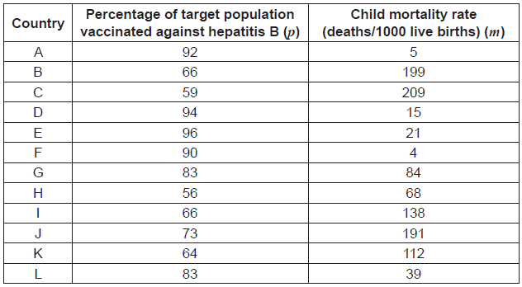
2. The information for the first six countries (A to F) has been plotted on the scatterplot below. Complete the scatterplot.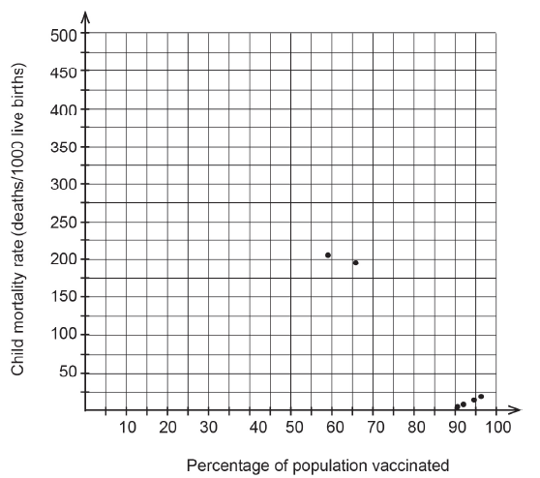

The equation for the least-squares line that models the relationship between the percentage of the target population vaccinated (*p*) and the child mortality rate (deaths per 1000 live births) (*m*) is

*m* = – 4.0808*p* + 403.959 and the correlation coefficient is *rpm* = – 0.7565.

1. Predict the child mortality rate where only a quarter of the target population has been vaccinated.

c) Comment on the reliability of your prediction from part (b). Give one reason to justify your answer.

1. (2 marks)  
     
   The first four terms of a sequence are −2, −8, −14, −20. Determine the sum to the eighth term of the sequence.
2. (10 marks: 1, 2, 3, 2, 2)  
     
   The original population (P) of a certain bacterium was 500. This population grew at a rate of 25% each year until it reached 9 095.
3. Which of the following equations could be used to model this growth?  
   1. P = 500(1.25)t t = 0, 1, 2…
   2. P = 500(0.25)t t = 0, 1, 2…
   3. P = 625(1.25)t t = 0, 1, 2…
   4. P = 500(5/4)t-1 t = 0, 1, 2…
4. How long did the population take to reach the size of 9 095?
5. When the population reached 9 095 the growth slowed to 10% per annum. This growth rate continued until the population was 23 590.How many years in total did it take to go from 500 to 23 590?
6. What constant annual percentage growth rate would have been needed to go from 500 to 23 590 in the same length of time? (Answer correct to 2 decimal places).
7. The population of 23 590 was unsustainable and once it reached that level it then declined steadily at 100 per month. How long (to the nearest month) would it take for the population to completely die out?
8. (8 marks: 2, 2, 3, 1)  
     
   The data in the following table show the estimated percentages of the population with access to fresh water and the cholera mortality rates for 10 countries.

|  |  |  |
| --- | --- | --- |
| Country | % Population with access to fresh water (P) | Cholera mortality rate  (per 100000 people) (C) |
| A | 27 | 164 |
| B | 43 | 81 |
| C | 64 | 69 |
| D | 51 | 103 |
| E | 55 | 65 |
| F | 38 | 154 |
| G | 34 | 136 |
| H | 50 | 113 |
| I | 85 | 73 |
| J | 78 | 61 |

##### Find the coefficient of linear correlation between P and C correct to four decimal places.

##### Calculate the equation of the least squares regression line of C on P correct to four decimal places.

##### Use the linear model to predict the cholera mortality rate in a country where an estimated 35 per cent of the population has access to fresh water. Comment on the accuracy of your prediction.

##### Comment on whether the given data support the following statement: ‘Improving access to fresh water in these countries causes a reduction in the cholera mortality rate’.

Extra space for working if required

**End of Test**